Cupboard door hinges

Sometimes when look at your kitchen or bedroom clothes cupboard doors, they just don’t look straight or they are catching on the floor when you open them etc…

Most cupboards today have got what they call “Concealed 180º Hinges”.

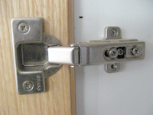

These hinges look quite complicated to adjust but when you know how they work then it becomes easy. I had a cupboard that got caught on the ground every time I opened the door so decided to do something about it before the door got too damaged.

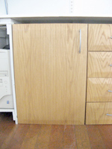

All you will need is a Phillips (star) screwdriver and some patience. Looking at the door from the front, it had a slight slope from left to right, so every time the door was opened, the opening end would get caught on the ground.

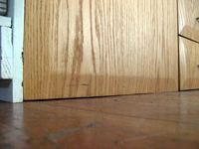

The door is held by 2 hinges, 1 at the top and 1 at the bottom.

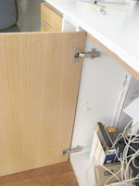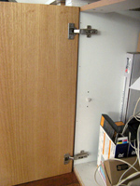

Step 1

Look at the hinges. You will see 3 screws on the hinge. Don’t worry about the middle screw at all. You need only concentrate on the left and right screw. Now because the door was getting caught on the floor on the opening end, working on the bottom hinge, I had to adjust these screws appropriately so that the door would not catch anymore. I loosened the right screw and then lifted the door so that the screw moved completely to the right. I fastened the screw again. I did no adjustments to the left screw yet. But this did not solve the problem yet. You will see on the picture that the right side screw has been shifted completely to the right when lifting the door.

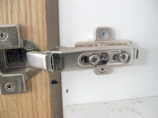

Step 2

On the top hinge, I loosened the screw on the right as well and lifted the door so that the screw was now positioned completed to the left of the casing and I fastened the screw again. You will see this in the picture.

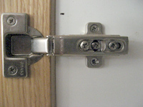

Step 3

After doing these adjustments, I closed the door to see how where it would still catch to the floor. I did this in order for me to know which other screws on which hinges I need to adjust. Upon closing the door, it caught to the floor just before closing completely so I opened it again.

On the bottom hinge, I unscrewed the left screw, being careful that I did not do it too much otherwise it would come out of the hole. On the top hinge, I fastened the left screw a bit. Now doing this, helps to straighten out the door better and lifts the door even more, especially when the door opens on the ground.

I closed the door this time and it did not catch to the ground and it was also straightened out in the process.

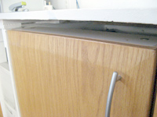

At the end of the day, how it works is as follows:

The screws on the right position the door so that is does not look skew, but this does not always work, therefore you need to adjust the screws on the left which not only lift or lower the door but also straighten it out so when you look at it, it is straight and level.

